Pokhara University

Level: Bachelor | Semester: Spring | Year : 2009
Programme: BE |  | Full Marks: 100
Course: Engineering Mathematics IV |  | Pass Marks: 45
 |  | Time : 3hrs.

Candidates are required to give their answers in their own words as far as practicable.
The figures in the margin indicate full marks.

Attempt all the questions.

 | - State and prove Cauchy's integral formula and use it to find 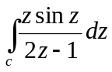where C is the unit circle counterclockwise.  - Show that 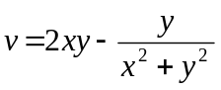 is harmonic function. find harmonic conjugate u of v. | 8  7
 | - Define residue of the complex valued function at their poles. State and prove Cauchy residue theorem. Evaluate 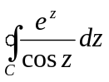, where C: the circle 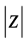= 3, in counterclockwise direction.  OR  State Cauchy integral formula. Evaluate the integral 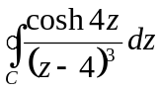, where C consists of = 6 (Counterclockwise) and 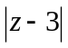= 2 (Clockwise).  - Define Z transform. State and prove linearity property of z transform. Using it find Z transform of cos at and then find Z transform of e^{bt} cos bt. | 8  7
 | - If 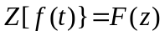, derive the expression of 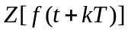. Evaluate 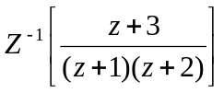.  - Solve: 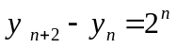 where 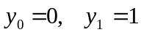 | 8  7
 | - Find u(x, t) from one dimensional wave equation 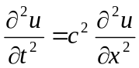, with boundary condition u (0, t) = 0 = u (L, t), initial deflection f (x) and initial velocity 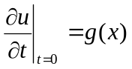.  - Find the temperature u (x, t), which is distributed laterally in a insulated copper bar (c² = 1.158cm² / sec), 100 cm long and of constant cross section whose end points at x = 0 and x = 100 are kept at 0ºC and its initial temperature is f (x) = sin³ (0.01). | 9  6
 | - Find the solution of two dimensional wave equation in circular membrane with necessary initial and boundary condition.  - Maximize z = 2x₁ + x₂, subject to 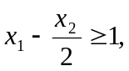x₁ – x₂ 2, x₁ – x₂ 4, x₁ 0, x₂ 0, by using simplex methods.  OR  Minimize z = 4x₁ + 3x₂, subject to 2x₁ + 3x₂ 1, 3x₁ + x₂ 4, x₁ 0, x₂ 0, by using simplex methods. | 8  7
 | - Find fourier Sine and Cosine transform of 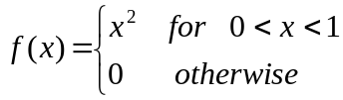  - Show that 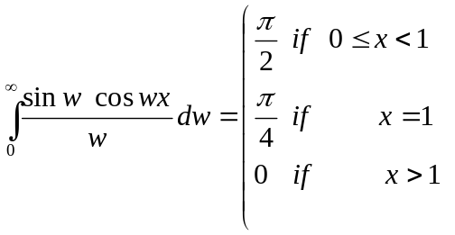 | 7  8
 | - Express the function f(z) = sinhz in the form of u+iv.  - Find the derivative of f(z) = 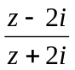 at z = i  - Prove Z(a^{n}) = 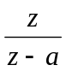  - State and prove linearity property of Z-transform i.e Z[a f (t) + bg(t)] = aZ {f(t)} + bZ {g(t)}.  - Verify u = e^{x} siny satisfies two dimensional Laplace. | 2  2  2  2  2

